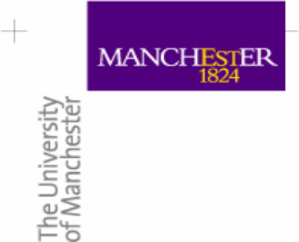 |  | 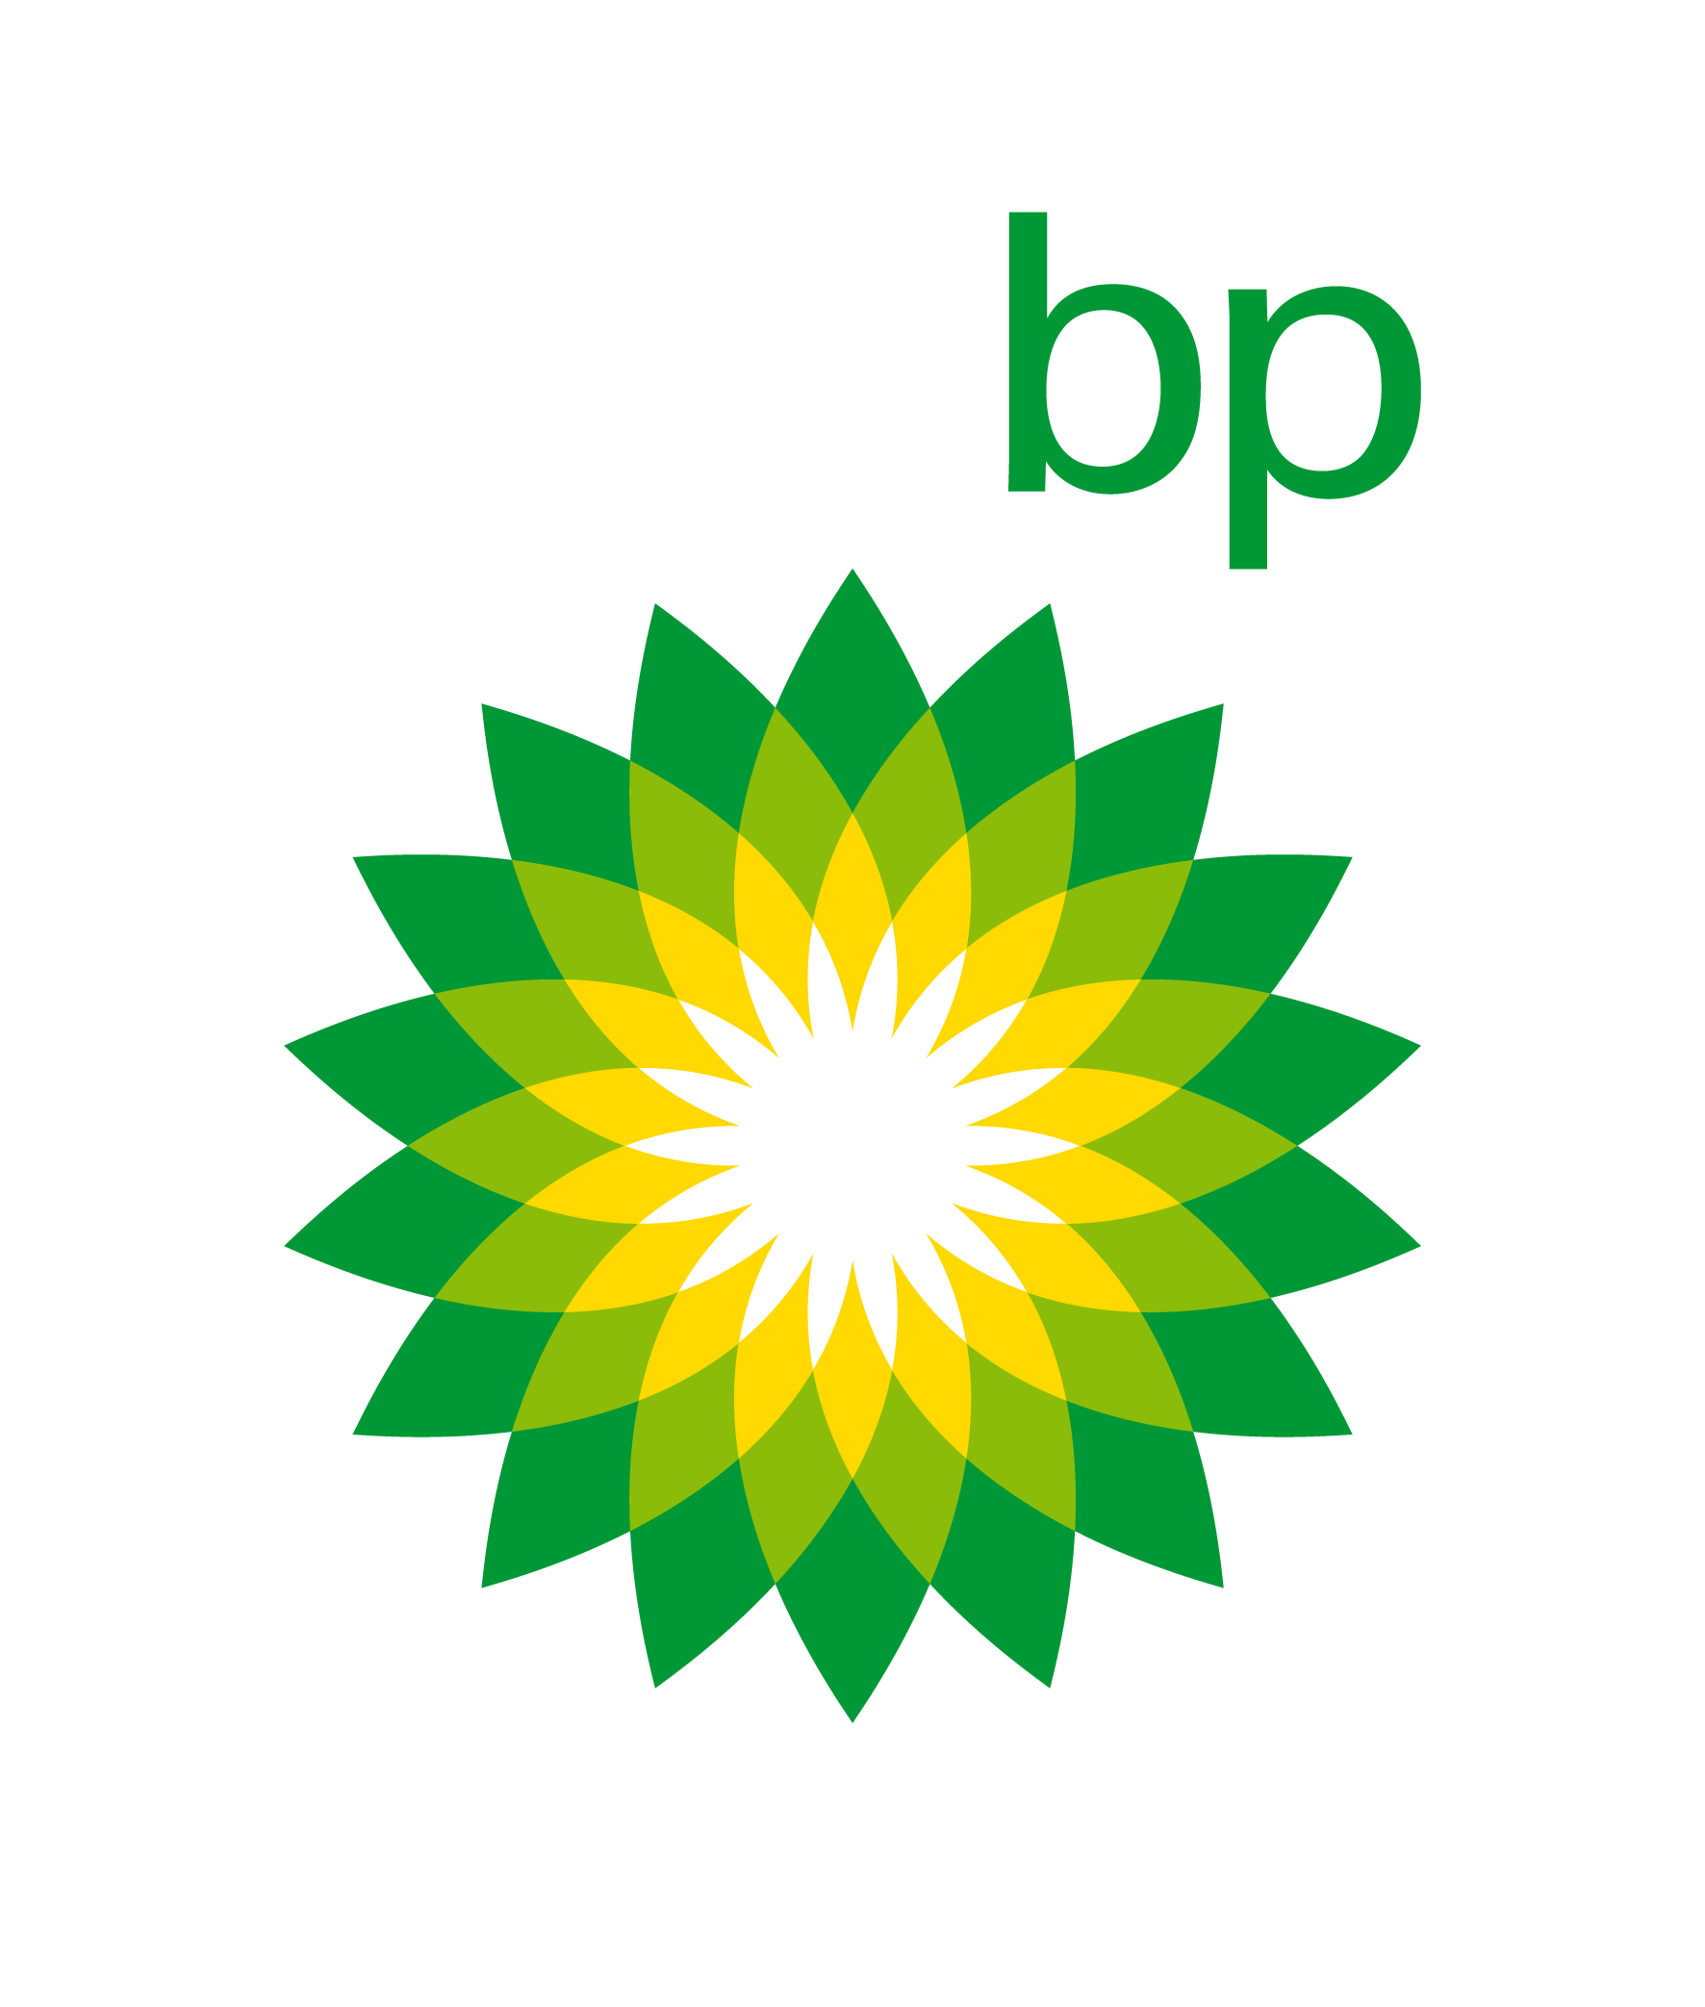
The University of Manchester is delighted to announce the launch of the bp Achievement Awards for 2021
Apply Now!
November 2020
As part of its relationship with bp, The University of Manchester is pleased to announce the launch of the 2021 Achievement Awards, sponsored by bp.

Aimed at Year 1 and Year 2 students in core Science, Engineering, Digital and Business disciplines the aim of the Achievement Awards is to recognize, reward and support academic excellence amongst students who have the potential to excel in their discipline. The value of each award is £800.

The winners of an Achievement Award, will also have the opportunity be considered for an 8-week paid project over the 2021 summer break, based at the University and sponsored by bp, provided they have expressed an interest in doing so on their application form, and the coronavirus restrictions in place at that time allow these to go ahead.

Successful applicants will also be offered a number of opportunities to meet a range of recent graduate hires and industry experts from bp and gain an insight into a wide variety of careers in the oil & gas industry.

When do I need to apply?
- Opening date = Monday 30 November 2020
- Closing date = Friday 19 February 2021

What do I need to do to apply?
- You need to be studying a Computer Sciences related degree.
- You need to be in Year 1 or Year 2 of your undergraduate course.
- You need to complete an Application Form which will include a 1,000 word essay.
- You need to submit your Application Form by 12 noon on Friday 19 February 2021.

What do I need to complete on the Application Form?
- Some basic details about yourself and the course you are studying.
- For Year 1, your ‘A’ Level results and expected 1st semester results.
- For Year 2, your 1st year exam results and your expected 1st semester results.
- Complete a 1,000 word essay on a question related to your discipline and / or the energy industry.

How will the Applications be judged?
- Members of staff from the department of Computer Sciences will assess all submitted applications.
- Your actual 1st semester exam results will be included in the Assessment. Your 1st Semester exam results should confirm you are on track for a 2:1 or above.
- In some cases it may be necessary to invite students to a short interview.

When will I hear if I have been successful?
- All students who have applied will hear whether they have been successful before the Easter break.
- The Awards will be presented by bp at an event to be held at the University in May 2021 subject to face-to face events being possible at that time.

How do I find out more information?
You can contact Duncan Hull duncan.hull@cs.man.ac.uk

About bp:

We deliver energy products and services around the world. From finding, developing and producing oil and gas resources, to refining, manufacturing and selling related products directly to customers and on the global markets, we keep modern life moving.

Today's growing world demands more energy, in new ways, with fewer emissions. As a global energy business, we’re working towards meeting this challenge – producing lower-carbon energy in a safe and sustainable way. Our aim is to reimagine energy for good, for the planet and everyone on it.

From engineers, technology developers and geoscientists to traders, HR professionals and commercial analysts, everyone at bp plays their part in making this aim a reality. Everyone on our early talent programmes is part of it too. After all, it’s only by bringing diverse people together in one, world-class team that we can succeed.

Our internship and graduate programmes are the perfect platform for new joiners to contribute, achieve their full potential, and become business leaders, leading scientists or ground-breaking engineers. Our paid 11-week and year-long internships offer hands-on business experience to undergraduates or postgraduates about to start the final year of their degree or PhD. Graduates on our two- or three-year programmes get to gain a full range of skills and experience too.

Diverse and inclusive, our culture focuses on teamwork, respect and ambition, as much as on academic achievements. So, right from the start, you’ll have opportunities to build a challenging, varied career whichever stage of the energy lifecycle you’re contributing to. The result is an environment where you can achieve your goals and drive progress, while making a meaningful impact for millions.

www.bp.com/careers

 |  |  | 

